Heart of America – Region 25
Summer Music Camp – Learning…Together!
SATURDAY, June 24, 2023
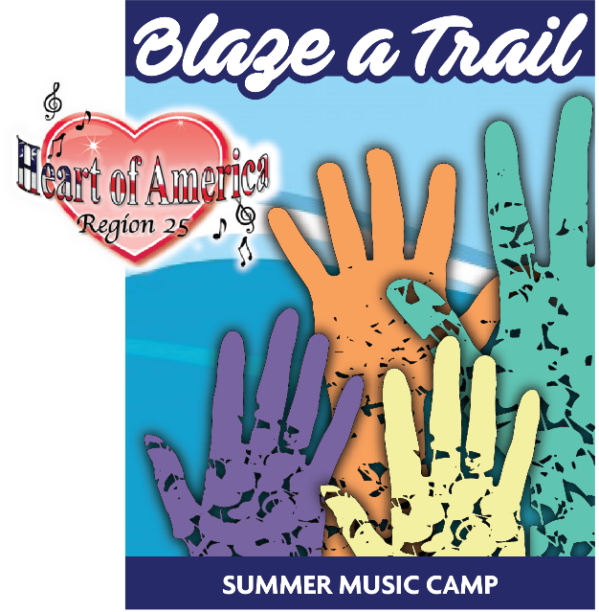
8:45-9:00 | General Assembly
9:00-9:30 | Music in the Morning  Dawn Krones, Jen LeClaire & Nicole Wilson
9:30-10:45 | Put the Best YOU in the UNIT  Ryan Heller  (Chorus Demo Group-Top of the Rock-Kelly Causey, director)
10:45-11:00 | B R E A K
Room #
11:00-12:00 | Breath & Beyond  Ryan Heller | Harmony in Design  Casey Lambert & Martha Thomason | I’m a Believer  Donna Smith | DCP – Q&A  Kelly Causey
Room #
12:00-1:30 | L U N C H | Communications,  Membership & Team Leaders  (Roundtable Discussions) |  | Assistant/Associate Directors  (Roundtable Discussion)  Tamara Boggs
Room #
1:30-2:30 | STAR Camp Chorus Rehearsal  Melynnie Williams & Donna Smith |  |  | Directing/Conducting Skills  Ryan Heller | PVI’s  Patty Friedemann & Pam Lauffer
2:30-2:45 | B R E A K
2:45-3:45 | Artistic Singing for Any Level  Ryan Heller  (Demo Quartet-Vocal Audacity)
3:45-4:00 | B R E A K
4:00-5:15 | Unleashing the Artist in You  Ryan Heller
5:15-7:30 | D I N N E R – On Your Own!
8:00-10:00 | THE BIG SHOW

