Heart of America – Region 25

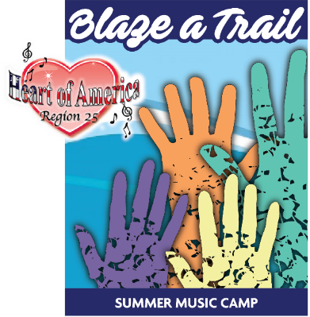
Summer Music Camp – Learning…Together!
FRIDAY, June 23, 2023

8:30-9:00 | General Assembly
9:00-9:30 | Music in the Morning  Dawn Krones & Erin Goeke
9:30-10:45 | Happy Together!  Lindsay Chartier
10:45-11-:00 | BREAK
Room #
11:00-12:00 | Matching your Skills with the Demands of your Music  Dale Syverson | Prepare Like An “A” Level Singer  Peggy Gram | Plan for the Future: Leadership Development & Succession Planning  Lindsay Chartier &  Connie Light | What is the Directors’ Certification Program?  Kelly Causey
Room #
12:00-1:30 | L U N C H | Directors Only, Events, Finance & Marketing  (Roundtable Discussions)
Room #
1:30-2:30 | Section Seminars  Tenor  Patty Friedemann & Dawn Krones | Section Seminars  Lead  Pam Lauffer &  Erin Goeke | Section Seminars  Baritone  Mary Rhea &  Jen Foster | Section Seminars  Bass  Melynnie Williams &  Jen LeClaire
2:30-2:45 | BREAK
Room#
2:45-4:00 | Energy!  Ryan Heller  (Demo Quartet-Wildfire!)
4:00-4:15 | BREAK
Room # | M
4:15-5:15 | Training the Trainers:  Music Team  Development  Ryan Heller | Finding Music  Kelli Hinton &  Dale Syverson | The Art of Communication  Peggy Gram | PVI’s  Patty Friedemann & Pam Lauffer
5:15-7:30 | D I N N E R – on Your Own!
7:45pm | All Work & No Play…No Way!  Mary Rhea & Donna Smith
Room #
8:30-9:30 | STAR Camp Chorus Rehearsal  Melynnie Williams & Donna Smith

