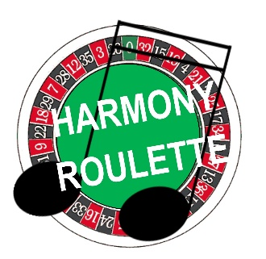
HARMONY ROULETTE
Region 25 – January 27-28, 2023

Harmony Roulette is making a return engagement at the Region 25 Quartet Retreat! What is Harmony Roulette, you ask? Harmony Roulette is a scaled down version of the Harmony Brigades you may have heard about. Here’s how it will work:

WHO? Single singers who are able to sing their part alone in a quartet. Each singer must be committed to being 100% prepared on both songs prior to the weekend.
WHAT? Singers will spend the day singing in many quartet combinations. Participants will learn both designated songs (totally off paper) prior to arrival at the Quartet Retreat. Singers will choose three other people to sing with, and then repeat the process until all possibilities are exhausted.
WHEN? Harmony Roulette singers will participate in the three classes with all other Quartet Retreat attendees, beginning on Friday evening. Harmony Roulette singers will have an orientation on Friday evening. Participants will have the opportunity to sing all day on Saturday as well as during the Saturday night festivities.
HOW? Twelve singers on each voice part will be accepted on a first come, first served basis. Registration will open on December 15. Singers will identify their voice part on the registration form as well as their second choice of voice part in case their first part has already been filled.
SCHEDULE:
Friday night:
Attend opening Quartet Retreat classes; Harmony Roulette activities will kick off with a group session and orientation.
Saturday:
Attend the two Quartet Retreat classes and vocal warm-up period.
Sessions 1-3: individuals will strive to sing each song with every other singer. At the end of session 3, there will be a random draw to assign quartets as well as the designated song each quartet will sing.
Session 4: quartets will rehearse their song, preparing to perform in session 5.
Session 5: quartets will sing for each other and choose the lucky quartet who will perform on Saturday evening. All participants will sing the remaining two songs as a chorus on Saturday evening.

HOW MUCH? Registration cost: $50. Your registration for Harmony Roulette serves as your registration for the Quartet Retreat – no additional fee required. Registration opens on December 15. Participants will be sent links to the SAI website to purchase their own copies of music. Learning tracks are included in the registration fee; they will be sent soon after registration is complete.
WHAT SONGS? Harmony Roulette participants will be responsible for purchasing their own legal copies of the songs we’ll use. Arrangements are all available on the SAI website; links will be sent with your confirmation. Learning tracks will be provided once registration is complete.
It’s My Song – arr. Jim Arns
We Can Work It Out – arr. Carolyn Schmidt

Questions? Contact Mary Rhea @ mary.rhea@att.net
Harmony Roulette is tons of fun! So much singing!

